**Android CA: The Memory Game**

**Requirements**

1. Only two Activities are required for this app.
2. The first Activity allows a URL to be specified. Clicking on the Fetch button will extract the first 20 images that it finds on the webpage that the URL points to and display the downloaded images in a grid. A progress-bar should show the number of images downloaded so far with description text (e.g. Downloading 10 of 20 images …)
3. The user can change the URL in the middle of a download and click on the Fetch button again. The current download would then be aborted and all images in the grid will be cleared. Repeat step 2 based on the new URL specified.

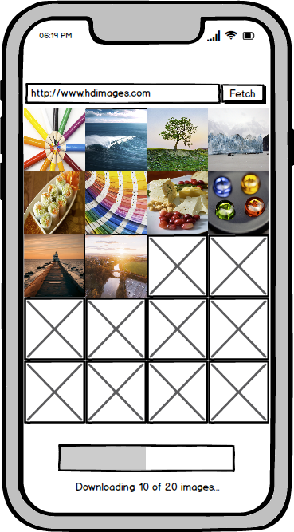

1. Recommended to use <https://stocksnap.io> as your URL source as the image extraction at that site is straightforward.
2. Once the first 20 images have been downloaded, allow the user to select 6 of them.

1. Once 6 images have been selected, bring the user to the second Activity.
2. The second Activity should look like this:

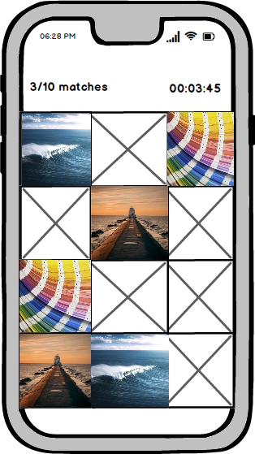

1. The second Activity will take the 6 selected images and use them for the memory game. In the beginning, display 12 placeholders. Then when a placeholder is touched, reveals the image behind that placeholder and wait for the second placeholder to be touched. When the user touched the second placeholder, reveals the image behind that placeholder. If both images are identical, leave both images as they are. If they are different, hide the two images and revert back to display the two placeholders.
2. The top left corner should display the matches so far and the top right corner should show a run-up timer.
3. When all images matches, return to the first Activity automatically. User can enter a different URL and download new images to play the game again.

**Marking**

1. Breakdown of marks:

|  | **Feature Set** | **Marks** |
| --- | --- | --- |
| 1. | Features that are specified in requirements | 25 |
| 2. | Features that your team finds interesting and creative | 5 (Extra Credit - Optional) |
|  | Total (Max) | **30** |

1. Ideas for interesting features:
   * Allows for two-player mode, where each player takes turn to play, with the winner being declared at the end
   * Adds special sound effects/animations when two images match or mis-match
2. The project is graded based on how well the code is engineered, the quality of the app (e.g. clean and pleasing visuals, app works according to requirements, no performance issues) and the quality of the video presentation (e.g. audio/video should be clear).

**Submission**

1. The following items need to be submitted
   * Project Code
   * Video demo
2. You should only submit a single zip file and named it as TeamXX.zip, where XX is your team number e.g. 01, 02, 12.
3. The submission date is 13 Jan 2024 (Sat), 6pm.